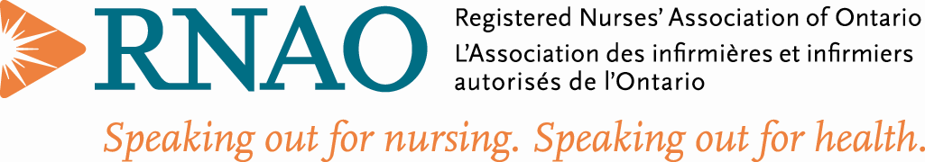
Retired Nurse Interest Group | Feb 2021
“Wisdom and Resilience- The Retired RN”  Notes from the Past Chair  Welcome to the 970th month of the pandemic!!  Doesn’t it feel like we have been doing this forever? The vaccine and the amount we have learnt over these last 11 months are rays of hope.  The RetNIG interest group has continued to provide updates and webinars to our members. We have decided to hold a brief business meeting before every webinar we host.  We hosted one in September, another in January and are excited by an upcoming webinar in March. Please keep tuned for information on this March 17th event focused on the impact of the pandemic on older adults – presented by Veronique Boscart.  Between Christmas and New Year’s, we put out a call for nominations for two executive positions- ENO Communication and Chair. We did not receive any applicants and are hoping this was just due to it being holiday times.  Our Social Media ENO is taking on some of the communication responsibilities, but we certainly need a new Chair.  Being RetNIG’s first chair – I am very committed to the continued success of this interest group. I want to be able to hand the reins over to another great RetNIG member. The chair position can be shared between two of our interest group members should people feel the responsibility would be too much. If you are interested to discuss further, please connect with me directly at seidmanr@rogers.com  As you will see in our Policy and Political Action ENO’s column that we are wanting to focus our political action activities on ways to support front line workers (RNs, NPs, and their team members). Please share ideas on how we might realize this goal.  RNAO AGM is in June 2021 and we will hold our AGM on Saturday June 26th. We are working on our focus for our AGM- your ideas would be greatly appreciated.  Take care, wash your hands, wear a mask (or two) and be safe.  Rhonda Seidman-Carlson  Past Chair Retired Nurses Interest Group (RetNIG)  Membership: RetNIG is a great investment at only $15/year  RetNIG, has 873 members: RN’s and NP’s: 111 and 762 Students.  To increase our membership, I ask each member to try and bring one member into our group. If we all did that, we could double our membership in one year.  During this Covid time we know that everyone has had difficulties be it financial, caregiving, grandparenting and/or working. Hats off to all the health care workers and we know that many of our members have come out of retirement to aid our healthcare system and for that we thank you!  Reasons to Join RetNIG:  - To stay in touch with the issues of the nursing profession today and for those who are retired to give back the wealth of knowledge that we know you all have.  - To influence policy changes for the healthcare system  - To provide retirement helpful hints to those who are planning retirement  - To provide mentorship if needed  - To have fun by staying in tune with our Nursing Family  - And for the Students we have a wealth of knowledge in this group if you have a question- if we do not know the answer, I am sure one of us knows someone who does.  We hope that you will participate in our Zoom AGM and give suggestions as to what you would like to see RetNIG do for you to keep you interested and engaged in our group.  Stay Safe and Healthy and Thank you for your membership!  Una Ferguson  Membership ENO  Finances:  TD Bank Balance today is $3,580.12 as of end of January 29/21. Still waiting for a membership deposit. Have not received anything yet from Home Office. Still awaiting their reply to my enquiry.  Marianne Cochrane  Financial ENO  Political Action:  Spring is known as the season of new beginnings and fresh starts. This season provides an opportunity for reflection on perseverance and self-care. Given what we have all endured over the past year. The recent accomplishments and demonstration of strength by nurses and other health-care professionals to provide care and maintain the integrity of the health system while coping with the Covid-19 pandemic has been nothing but heroic. The impacts of learning and implementing new protocols, new expectations, personal fears and the unknown of the Covid-19 virus can be overwhelming.  Over the years, workload and patient complexity has increased, making the expectations of care-delivery more challenging. Nurses often put others before themselves, and even with assistant programs and in-services about self-care and balance, time for self-care may become secondary amidst fatigue, home-schooling, family time and work, resulting in exhaustion and feeling overwhelmed.  Taking care of yourselves should not be an afterthought. As such an area of focus for political action through RETNIG is seeking support to address the self-care needs of health-care workers impacted by the pandemic. Our first step is to consult with you in identifying which of the following initiatives will provide you with additional support to care for yourself while meeting the challenges that health-care professionals face:  1. A collaborative event with Mental Health Nurses Interest Group and Staff Nurses Interest Group around the impact of the pandemic on frontline staff; and staff accessing resources without being stigmatized.  2. Collaborate and advocate for the assessment of psychological needs of nurses and health-care workers to facilitate additional initiatives for self-care.  3. Advocate at political tables for enhanced benefits to support ongoing psychological care.  4. Ongoing events on mental health and self-care.  To participate in this short survey please follow this link https://myrnao.ca/retnig_selfcare_survey_2020  The impact of the COVID-19 pandemic has also created additional strain on residents, staff, and family members in the long-term care sector. Dr. Veronique Boscart will discuss the current situation in long-term care homes via Webinar on March 17, 2021 5:15-6:30. Watch for the registration e-mail and check the RNAO events page for additional detail. https://rnao.ca/events  Althea Stewart  Policy and Political Action ENO  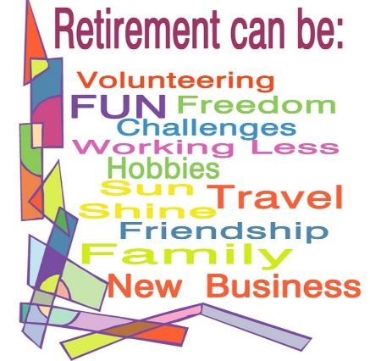  A Final Word  Please remember to follow us on Facebook and Twitter. Our social media information can be found below: | “Retire from your job, but never retire your mind!” unknown author
 | 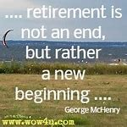

http:/ /rnao.ca/connect/interest-groups/retired-nurses-interest-group-retnig

